SaaS vs PaaS vs IaaS

Cloud computing offers services in three primary categories, each representing a different level of management and control for the user. Understanding these models is crucial for choosing the right solution for a business or a project.

**IaaS (Infrastructure as a Service)** offers basic, on-demand IT infrastructure like storage, networks, and virtualization, requiring the user to manage operating systems and applications.

**PaaS (Platform as a Service)** provides a full platform to develop, run, and manage applications, including hardware and software tools, but the user manages the applications and data.

**SaaS (Software as a Service)** delivers complete software applications over the internet, where the vendor handles all the underlying infrastructure, platform, and application maintenance, and the user simply focuses on using the software.

# Software as a Service (SaaS)

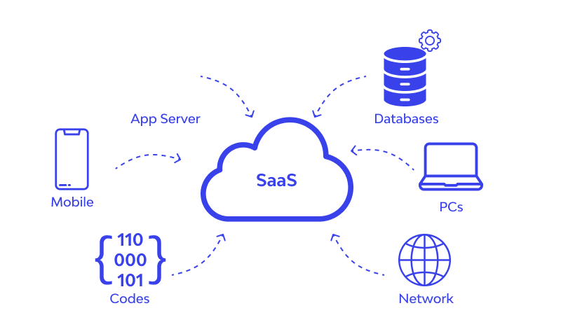

Software as a Service (SaaS) is the most user-friendly model, providing complete software applications hosted in the cloud. Instead of purchasing and installing software on individual devices, users can access applications over the internet. SaaS eliminates the need for businesses to install, maintain, or manage software themselves.

In simple words, if you have no experience in coding, you can hire a third-party cloud service to build both the front end and back end of your application along with handling your connectivity.

**What the Provider Manages**:

* Everything! All layers of the stack, from the infrastructure to the application itself.

**What You Manage**:

* Your data within the application.

**Key Characteristics & Use Cases**:

* Ease of Use: No installation, updates, or maintenance are required. You simply log in and use the software.
* Subscription-Based: SaaS is almost always billed on a subscription or pay-per-use model, making it a predictable operational expense.
* Examples: Google Workspace (Gmail, Docs), Salesforce, Dropbox, Microsoft 365, Netflix.

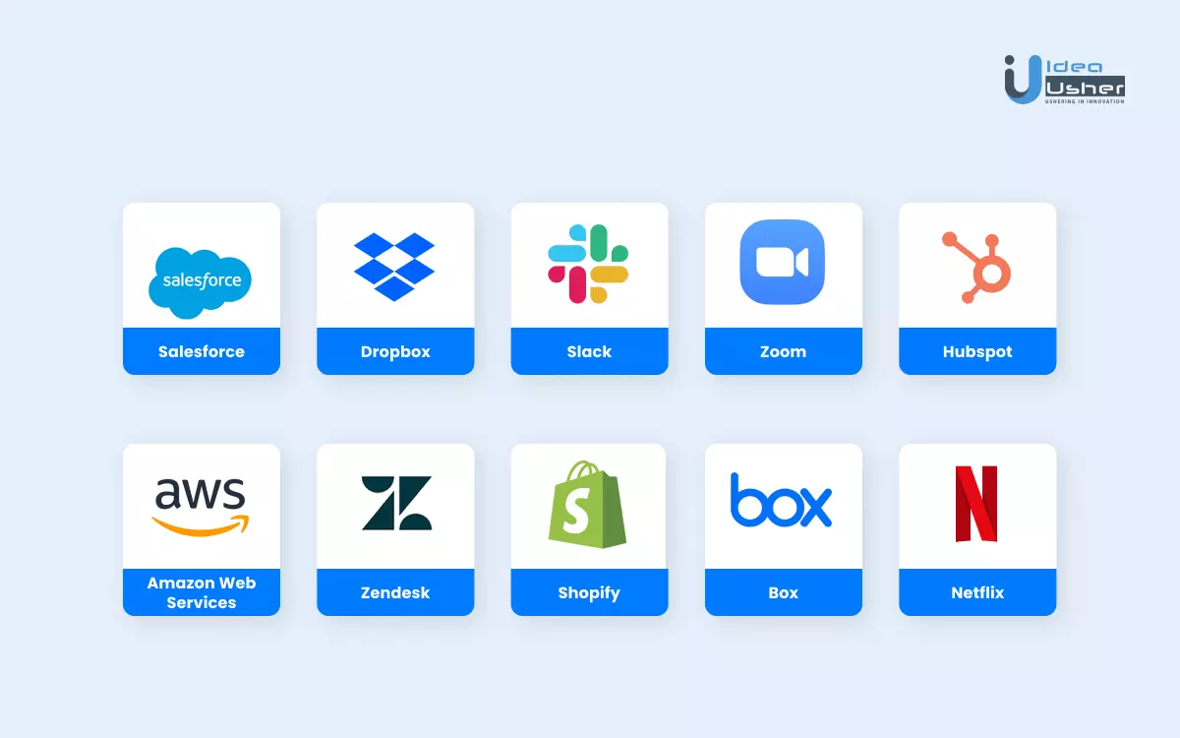

# Platform as a Service (PaaS)

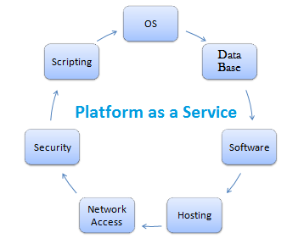

Platform as a Service (PaaS) offers a cloud environment for developing, running, and managing applications without dealing with the complexities of maintaining the underlying infrastructure. It provides a platform that includes tools for app development, hosting, and runtime management. PaaS is aimed at developers who want to focus on building applications rather than managing hardware or operating systems.

In simpler terms, if you're familiar with coding languages like .NET or PHP and know how to create databases, but you need a platform to work on, you can use the .NET or PHP platforms. By using your own coding skills, you can build a website or app on their platform.

**What the Provider Manages**:

* Networking, Storage, Servers, and Virtualization
* Operating System
* Middleware
* Runtime

**What You Manage**:

* Applications
* Data

**Key Characteristics & Use Cases**:

* Simplified Development: PaaS streamlines the entire development lifecycle, enabling faster time-to-market for new applications.
* Collaboration: It's great for multi-developer projects as it provides a standardized, shared environment.
* Examples: Heroku, Google App Engine, Microsoft Azure App Service.

# Infrastructure as a Service (IaaS)

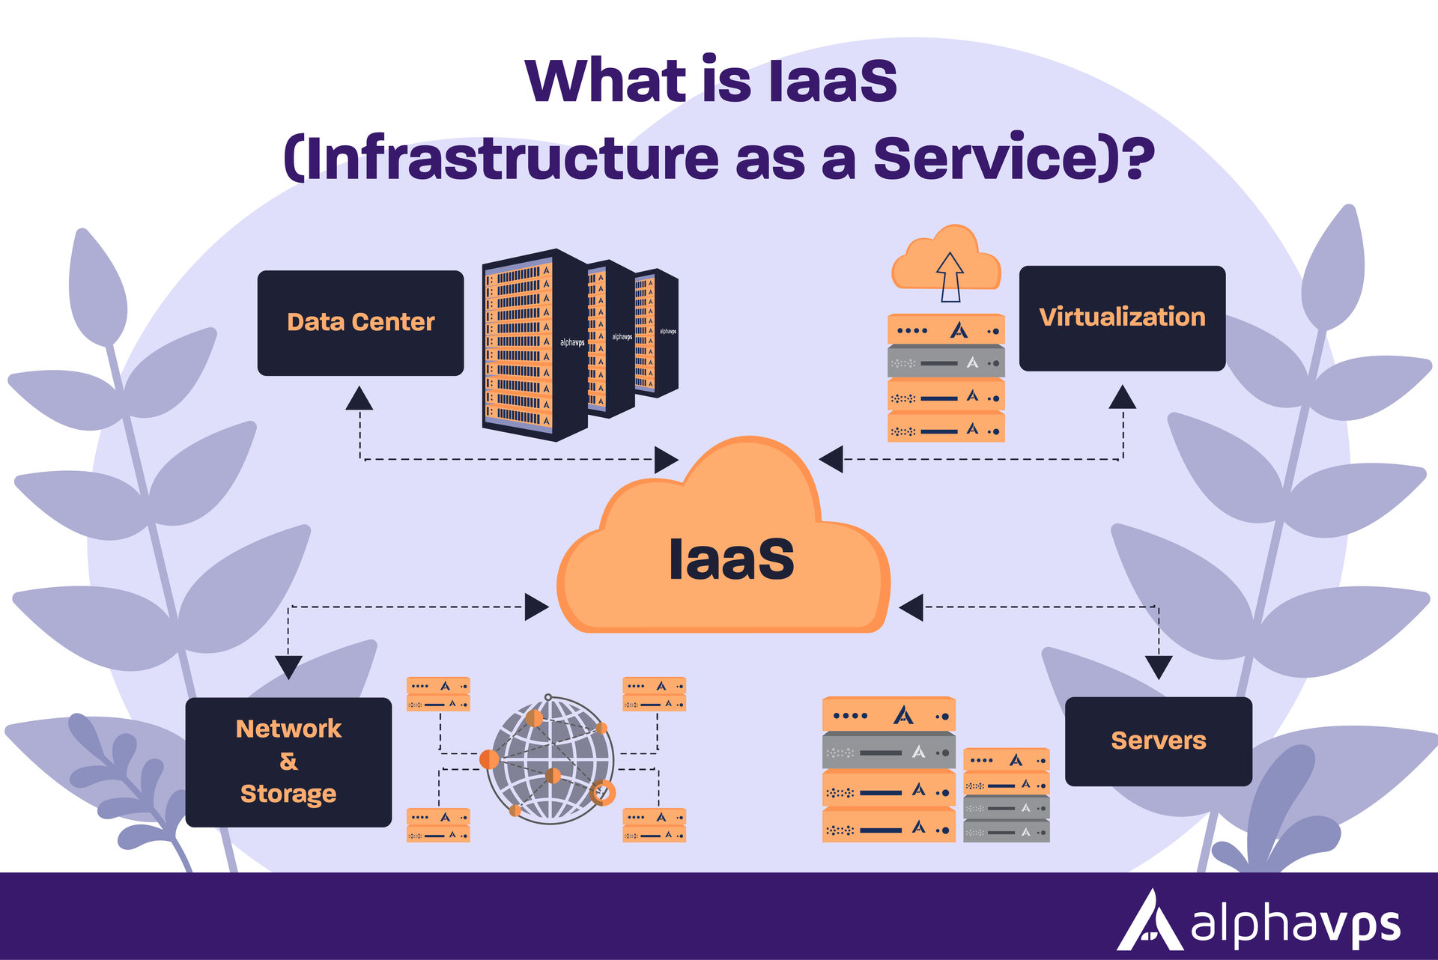

Infrastructure as a Service (IaaS) is a cloud service model that provides virtualized computing resources over the internet. It delivers essential infrastructure components such as servers, storage, networking, and computing resources on a pay-as-you-go use basis.

**What the Provider Manages**:

* Networking
* Storage
* Servers
* Virtualization

**What You Manage**:

* Operating System
* Middleware (e.g., databases, web servers)
* Runtime (e.g., Java, .NET)
* Applications
* Data

**Key Characteristics & Use Cases**:

* Maximum Control: IaaS provides the greatest flexibility and control over your IT resources. You can customize everything from the operating system to the installed software.
* Cost-Effective for Migration: It's ideal for "lift-and-shift" migrations, where you move existing applications from an on-premises data center to the cloud without redesigning them.
* Examples: Amazon Web Services (AWS) EC2, Google Compute Engine (GCE), Microsoft Azure Virtual Machines.

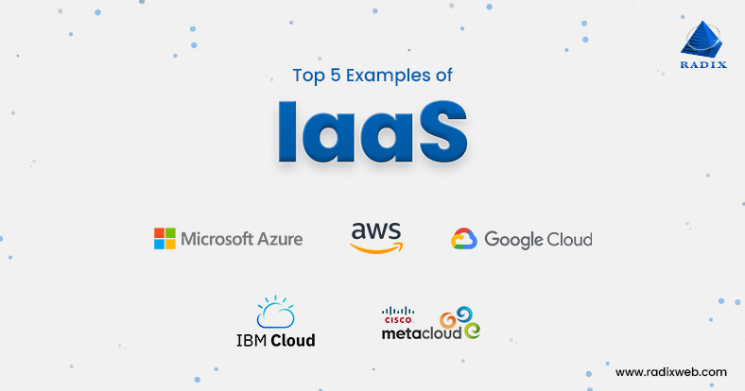

# SaaS vs PaaS vs IaaS

